Potential solutions to bias in AI/ ML

General rules.

Things to consider when designing an AI model.

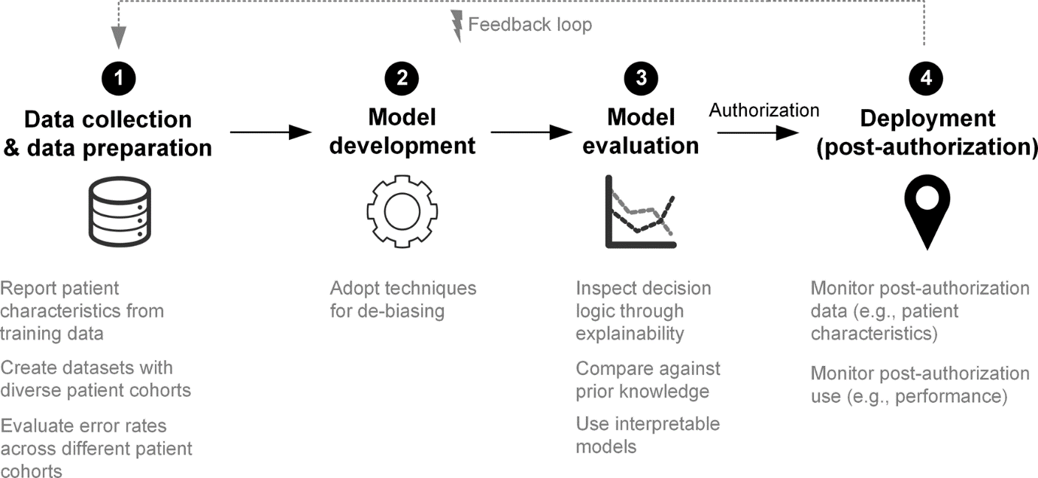

Ways to avoid AI bias in medicine.

Sources:

<https://www.mckinsey.com/featured-insights/artificial-intelligence/tackling-bias-in-artificial-intelligence-and-in-humans>

<https://www.allerin.com/blog/ai-can-reinforce-existing-human-biases>

<https://www.nature.com/articles/s43856-021-00028-w>